Experiment 11: write a Python program to implement the Map Coloring Problem using the Constraint Satisfaction Problem (CSP)

Aim
To write a Python program to implement the Map Coloring Problem using the Constraint Satisfaction Problem (CSP) approach.

Algorithm
- Define the map with its neighboring regions.
- Define the available colors.
- Assign a color to each region.
- Check whether the assigned color is different from its neighboring regions.
- If the color assignment is valid, proceed to the next region.
- Otherwise, backtrack and try another color.
- Display the color assigned to each region.

Program
graph = {
'A': ['B', 'C'],
'B': ['A', 'C', 'D'],
'C': ['A', 'B', 'D'],
'D': ['B', 'C']
}

colors = ['Red', 'Green', 'Blue']

solution = {}

def is_safe(node, color):
for neighbour in graph[node]:
if neighbour in solution and solution[neighbour] == color:
return False
return True

def map_coloring(node_list, index):
if index == len(node_list):
return True

node = node_list[index]

for color in colors:
if is_safe(node, color):
solution[node] = color

if map_coloring(node_list, index + 1):
return True

del solution[node]

return False

nodes = list(graph.keys())

if map_coloring(nodes, 0):
print("Color Assignment:")
for node in nodes:
print(node, "=", solution[node])
else:
print("No Solution")

Output
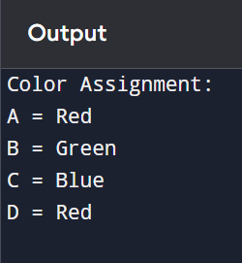

Result
Thus, the Python program to implement the Map Coloring Problem using Constraint Satisfaction Problem (CSP) was executed successfully, and valid colors were assigned to all regions without violating the constraints.

